Parsing an XML RSS Feed

1.0: Understanding What You Are Parsing

[RSS](http://en.wikipedia.org/wiki/RSS) stands for Really Simple Syndication. It is a web feed put into a standard XML format with certain tags that are used to pull information easily from a web site. Most RSS feeds are public and the topics distributed can range from blog feeds, podcasts, video casts, or other information that is updated regularly. It has a URL that can be used to find the latest updates of information. An example of an RSS feed can be the Netflix Top 100 movies feed. This feed obviously changes all of the time and we can write an iPhone app that displays the top 100 movies and some detail information on each movie. The below example is the XML output of the Netflix Top 100 RSS feed: <http://rss.netflix.com/Top100RSS>.

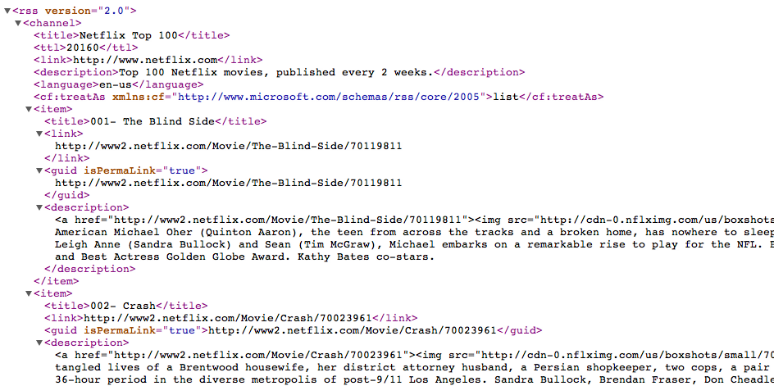

The channel element consists of some header information on the feed; such as title, link, and description. Then there is a list of 100 items that consists of elements; such as title, link to movie thumbnail, and description.

2.0: Creating a Class to Parse an XML File

Parsing is a pretty straightforward process; however, it takes time to understand the needed classes and datatypes to handle the parsing of the XML file. In this first example, we will create a console application that reads an RSS feed and displays the information needed.

* NSXMLParser datatype overview
* NSURL datatype overview

***Step 1:*** Create a Console Application

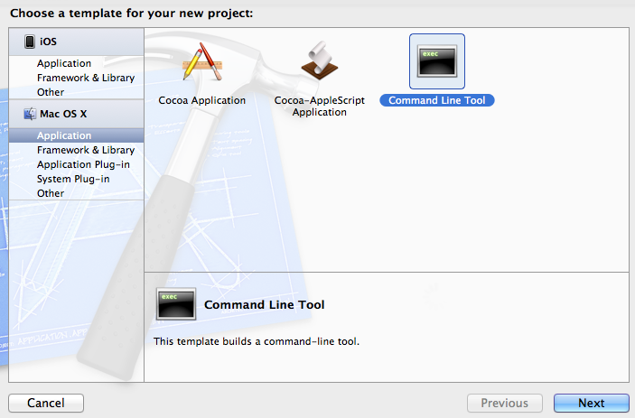

***Step 2:*** Name the project, for this example we will use, “RSSConsoleExample”. Make sure to keep the default type as a Foundation program.

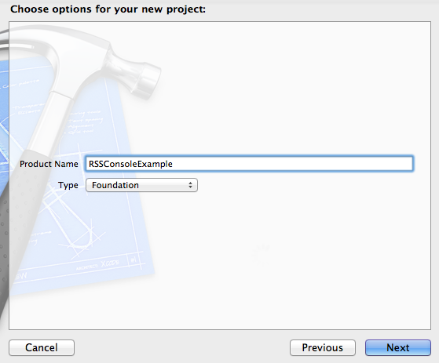

***Step 3A:*** Add an Objective-C Class to handle the parsing.

|  |  |
| --- | --- |
|  |  |

***Step 3B:*** Name the new class Parser and make it a subclass of NSObject.

|  |  |
| --- | --- |
|  |  |

***Step 4:*** Add the header information for Parser.h

#import <Foundation/Foundation.h>

@interface Parser : NSObject <NSXMLParserDelegate>

{

NSXMLParser *rssParser;

NSMutableArray *movies;

NSMutableDictionary *item;

NSString *currentElement;

NSMutableString *currentTitle, *currentDate;

NSMutableString *currentSummary, *currentLink;

}

-(void) parseXMLFileAtURL:(NSString *)URL;

@end

***Step 5:*** Change init method to write a string to show us that the Parser class is being called.

- (id)init

{

self = [super init];

if (self)

{

NSLog(@"Found file and started parsing.");

}

return self;

}

***Step 6:*** Create parseXMLFileAtURL method to populate the movies array

- (void)parseXMLFileAtURL:(NSString *)URL

{

movies = [[NSMutableArray alloc] init];

NSURL *xmlURL = [NSURL URLWithString:URL];

rssParser = [[NSXMLParser alloc] initWithContentsOfURL:xmlURL];

[rssParser setDelegate:self]; //Receive callbacks

[rssParser parse];

}

***Step 7:*** Create parser override method to handle potential errors with the RSS feed

- (void)parser:(NSXMLParser *)parser

parseErrorOccurred:(NSError *)parseError

{

NSString *errorString = [NSString stringWithFormat:@"Unable to

download movie feed from web site (Error code %i)",

[parseError code]];

NSLog(@"Error parsing XML: %@", errorString);

}

***Step 8:*** Create a parser method the handles the XML element and initializes the item dictionary.

- (void)parser:(NSXMLParser *)parser

didStartElement:(NSString *)elementName

namespaceURI:(NSString *)namespaceURI

qualifiedName:(NSString *)qName

attributes:(NSDictionary *)attributeDict

{

NSLog(@"Found this element: %@", elementName);

currentElement = [elementName copy];

if ([elementName isEqualToString:@"item"])

{

item = [[NSMutableDictionary alloc] init];

currentTitle = [[NSMutableString alloc] init];

currentSummary = [[NSMutableString alloc] init];

currentLink = [[NSMutableString alloc] init];

}

}

***Step 9:*** Create a parser class that handles setting the elements in the item dictionary. This class allows for us to look inside the item element to parse out the title, link, and summary. Once we have that information, we will add it to the movies array.

- (void)parser:(NSXMLParser *)parser

didEndElement:(NSString *)elementName

namespaceURI:(NSString *)namespaceURI

qualifiedName:(NSString *)qName

{

NSLog(@"Ended element: %@", elementName);

if ([elementName isEqualToString:@"item"])

{

// save values to an item, then store into array...

[item setObject:currentTitle forKey:@"title"];

[item setObject:currentLink forKey:@"link"];

[item setObject:currentSummary forKey:@"summary"];

[movies addObject:[item copy]];

NSLog(@"Adding movie: %@", currentTitle);

// NSLog(@"Summary: %@", currentSummary);

// NSLog(@"Link: %@", currentLink);

}

}

***Step 10:*** This is the real brain of the operation. We are using this parser class to filter through the elements that we are most interested in; which is the title, link, and description. Since we initialized this variables in Step 8, we can now look at the current element and add to our strings depending on the element that we find.

- (void)parser:(NSXMLParser *)parser foundCharacters:(NSString *)string

{

NSLog(@"Found characters: %@", string);

// save the characters for the current item...

if ([currentElement isEqualToString:@"title"])

{

[currentTitle appendString:string];

}

else if ([currentElement isEqualToString:@"link"])

{

[currentLink appendString:string];

}

else if ([currentElement isEqualToString:@"description"])

{

[currentSummary appendString:string];

}

}

***Step 11:*** Let’s create the class to see if we are all done.

- (void)parserDidEndDocument:(NSXMLParser *)parser

{

NSLog(@"All done!");

NSLog(@"Movies array has %lu items", [movies count]);

}

***Now call new class from main.m:*** We now have an object-oriented class that we will be able to use outside of our console program in the future. However, we will modify our main class to call this class within the console program. Open the main.m class and make the following changes:

#import <Foundation/Foundation.h>

#import "Parser.h"

int main (int argc, const char * argv[])

{

NSString *path = @"http://rss.netflix.com/Top100RSS";

// Initialize Parser class and run parseXMLFileAtURL

Parser *myParser = [[Parser alloc] init];

[myParser parseXMLFileAtURL:path];

return 0;

}

3.0: Use our Parser Class to Populate a UITableView

Now that we have created a parser class and executed it in the console app, we can now copy the parser class into a new project to display a UITableView and Detail screen. The following steps are very similar to that of Example 5 in the 010iTableViewPart1 handout.

***Step 1:*** Create a new Navigation-based Application

|  |  |
| --- | --- |
|  |  |

***Step 2:*** Navigate to the Navigation Bar on the MainWindow.xib file

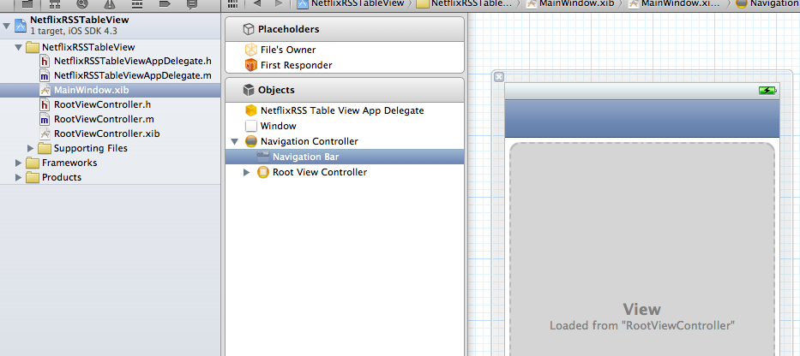

***Step 3:*** Change the Navigation Bar tint to [Red] to match the Netflix theme colors

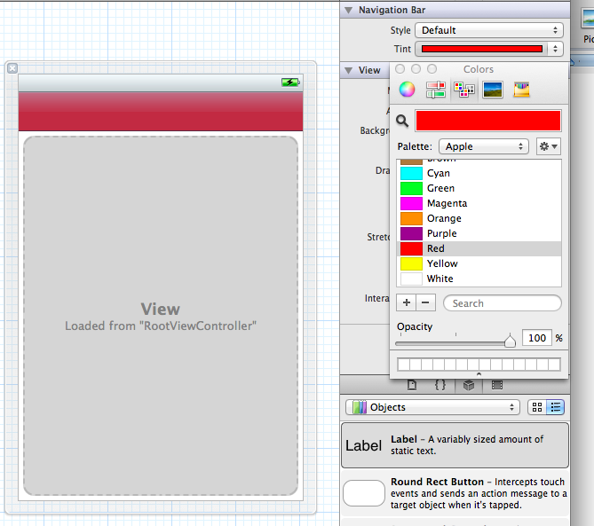

***Step 4:*** Change the title to the Navigation Item to read “Netflix Top 100”

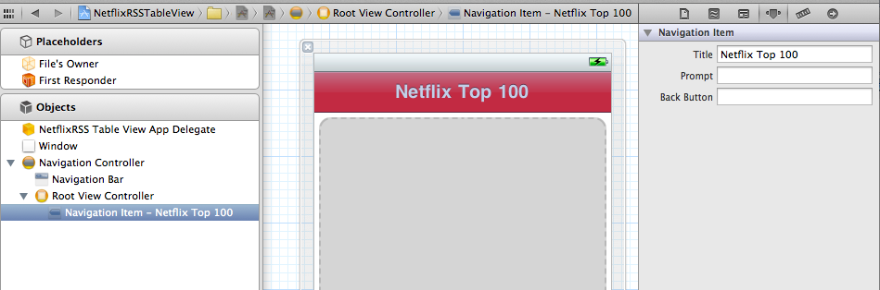

***Step 5:*** Change the RootViewController.h file to include the [items] array

@interface RootViewController : UITableViewController

{

NSMutableArray *items;

}

@property (retain, nonatomic) NSMutableArray *items;

***Step 6:*** Change the number of rows in the table by modifying the following method’s return.

- (NSInteger)tableView:(UITableView *)tableView

numberOfRowsInSection:(NSInteger)section

{

return [items count];

}

***Step 7:*** Add the Parser Class that we created in the console app to your project under the Supporting Files group. Make sure that the [Copy items] box is checked.

|  |  |
| --- | --- |
|  |  |

***Step 8:*** Let’s modify the Parser class to make the movies array accessible. This is a problem with the original creation in the class and “in the real world”, we would modify the original class before including in this new class. This is also a good example on why you would use a reference of a class in a corporate or consolidated development environment.

@interface Parser : NSObject <NSXMLParserDelegate>

{

NSXMLParser *rssParser;

NSMutableArray *movies;

NSMutableDictionary *item;

NSString *currentElement;

NSMutableString *currentTitle, *currentDate, *currentSummary, *currentLink;

}

@property (nonatomic, retain) NSMutableArray *movies;

-(void) parseXMLFileAtURL:(NSString *)URL;

We will synthesize the object in the implementation file [Parser.m]

@implementation Parser

@synthesize movies;

***Step 9:*** Go back to the RootViewController.m and synthesize the items object we created in step 5. We also want to import the Parser.h class to have access to it.

#import "RootViewController.h"

#import "Parser.h"

@implementation RootViewController

@synthesize items;

***Step 10A:*** Make sure that we have the loadData added to the RootViewController.h header file. We will use this to load the data into the items array.

#import <UIKit/UIKit.h>

@interface RootViewController : UITableViewController

{

NSMutableArray *items;

}

@property (retain, nonatomic) NSMutableArray *items;

- (void)loadData;

@end

***Step 10B:*** Inside the RootViewController.m, let’s add the loadData method and receivedItems handler.

- (void)loadData

{

if (items == nil)

{

Parser *rssParser = [[Parser alloc] init];

[rssParser parseXMLFileAtURL:@"http://rss.netflix.com/Top100RSS"];

items = [rssParser movies];

}

else

{

[self.tableView reloadData];

}

}

- (void)receivedItems:(NSMutableArray *)theItems

{

items = theItems;

[self.tableView reloadData];

}

***Step 11:*** Inside the RootViewController.m, let’s configure the cell’s label by adding the highlighted line below.

- (UITableViewCell *)tableView:(UITableView *)tableView

cellForRowAtIndexPath:(NSIndexPath *)indexPath

{

static NSString *CellIdentifier = @"Cell";

UITableViewCell *cell = [tableView dequeueReusableCellWithIdentifier:CellIdentifier];

if (cell == nil) {

cell = [[[UITableViewCell alloc] initWithStyle:UITableViewCellStyleDefault reuseIdentifier:CellIdentifier] autorelease];

}

// Configure the cell.

cell.textLabel.text = [[items objectAtIndex:indexPath.row] objectForKey:@"title"];

return cell;

}

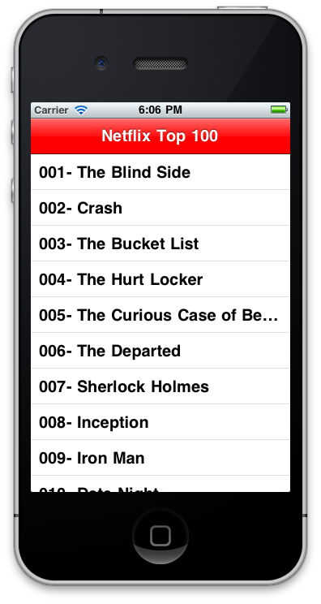

At this point we should be able to see the initial table view populated.

***Step 12A:*** Our next step is to add the detail controller and screen. This will be a xib file that has the title and a Web Viewer object that renders the HTML description from the array. Add a new file to the project and select the UIViewController subclass

|  |  |
| --- | --- |
|  |  |

***Step 12B:*** Make sure to select UIViewController as the subclass and name the controller “DetailController”

|  |  |
| --- | --- |
|  |  |

***Step 13:*** Inside the DetailController.h file, we will need to change the header to setup the blueprint for controller. This consists of our two outlets and the dictionary that we are working with.

@interface DetailController : UIViewController

{

NSDictionary *item;

IBOutlet UILabel *itemTitle;

IBOutlet UIWebView *itemSummary;

}

@property (retain, nonatomic) NSDictionary *item;

@property (retain, nonatomic) IBOutlet UILabel *itemTitle;

@property (retain, nonatomic) IBOutlet UIWebView *itemSummary;

- (id)initWithItem:(NSDictionary *)theItem;

Step 14: Inside the DetailController.m file, we will replace the initWithNibName method with the following initWithItem class. This allows us to pass the dictionary to the detail XIB file.

- (id)initWithItem:(NSDictionary *)theItem {

if (self = [super initWithNibName:@"DetailController" bundle:nil]) {

self.item = theItem;

self.title = [item objectForKey:@"title"];

}

return self;

}

***Step 15:*** Inside the DetailController.m file, modify the viewDidLoad and dealloc to add the title and summary. Obviously, we will release inside the dealloc. We will also need to make sure that we are importing the DetailController.h

#import "DetailController.h"

- (void)viewDidLoad

{

[super viewDidLoad];

self.itemTitle.text = [item objectForKey:@"title"];

[self.itemSummary loadHTMLString:[item objectForKey:@"summary"] baseURL:nil];

}

- (void)dealloc {

[item release];

[itemTitle release];

[itemSummary release];

[super dealloc];

}

***Step 16:*** Add the label and the UIWebView to the DetailController.xib file.

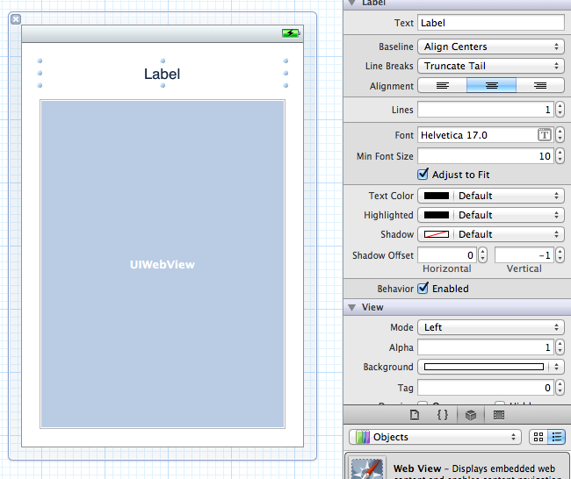

***Step 17:*** Link your outlets to the title and summary fields just created.

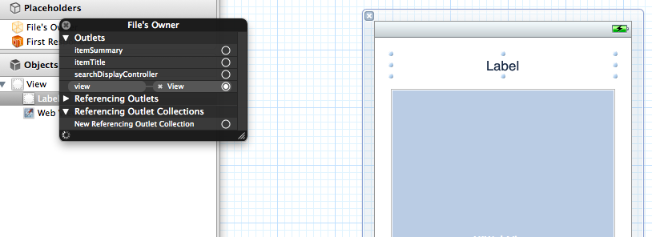

***Step 18:*** Now lets finish up the RootViewController.m file by adding the following code to the outstanding methods.

#import "RootViewController.h"

#import "Parser.h"

#import "DetailController.h"

@implementation RootViewController

@synthesize items;

// Customize the appearance of table view cells.

- (UITableViewCell *)tableView:(UITableView *)tableView cellForRowAtIndexPath:(NSIndexPath *)indexPath

{

static NSString *CellIdentifier = @"Cell";

UITableViewCell *cell = [tableView dequeueReusableCellWithIdentifier:CellIdentifier];

if (cell == nil)

{

cell = [[[UITableViewCell alloc] initWithStyle:UITableViewCellStyleDefault reuseIdentifier:CellIdentifier] autorelease];

}

// Configure the cell.

cell.textLabel.text = [[items objectAtIndex:indexPath.row] objectForKey:@"title"];

return cell;

}

- (void)tableView:(UITableView *)tableView didSelectRowAtIndexPath:(NSIndexPath *)indexPath

{

NSDictionary *theItem = [items objectAtIndex:indexPath.row];

DetailController *nextController = [[DetailController alloc] initWithItem:theItem];

[self.navigationController pushViewController:nextController animated:YES];

[nextController release];

}

- (void)viewDidLoad

{

[super viewDidLoad];

UIBarButtonItem *rightButton = [[UIBarButtonItem alloc] init];

self.navigationItem.rightBarButtonItem = rightButton;

[rightButton release];

}

- (void)viewWillAppear:(BOOL)animated

{

[super viewWillAppear:animated];

}

- (void)dealloc

{

[items release];

[super dealloc];

}

@end

4.0: Evaluate and Parse a JSON Feed

JSON pronounce [Jay Sawn] stands for JavaScript Object Notation. Just as news outlets and subscription services use XML RSS feeds, JSON is the preferred web-publishing notation used by developers. Many web sites and services create an Application Programming Interface (API) to customize, create a mobile app, or some other interface.

For example, [Rottentomatoes.com](http://rottentomatoes.com) is a web site that provides ratings, reviews, and other movie data. It is a great web site, but I may want to create a mobile application that quickly pulls the data based on the same search. The development team has created an API that allows us to interface with their data. Here is an example of using their web interface to search on the movie *Forrest Gump*.

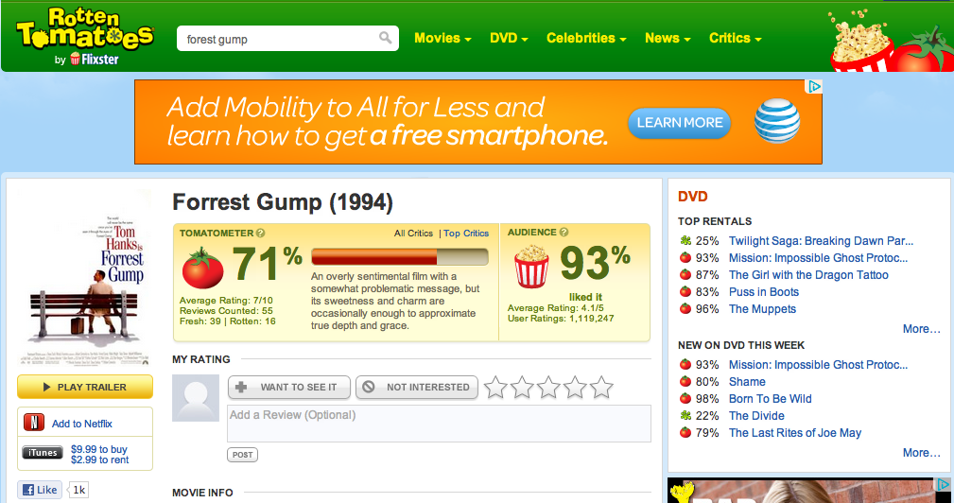

Here is an example of the JSON created from that same search.

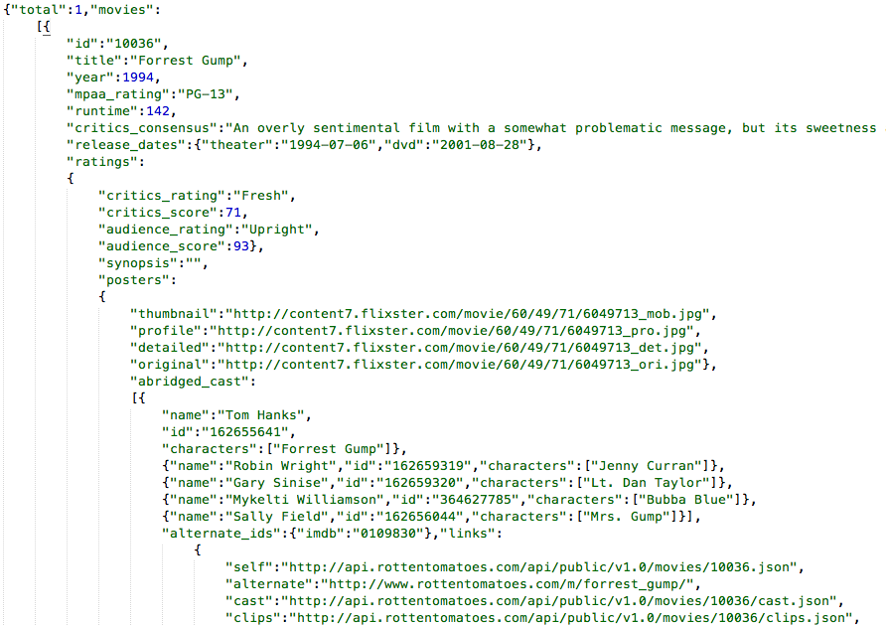

As illustrated on the json.org website, here are the different forms and structure of a JSON file.

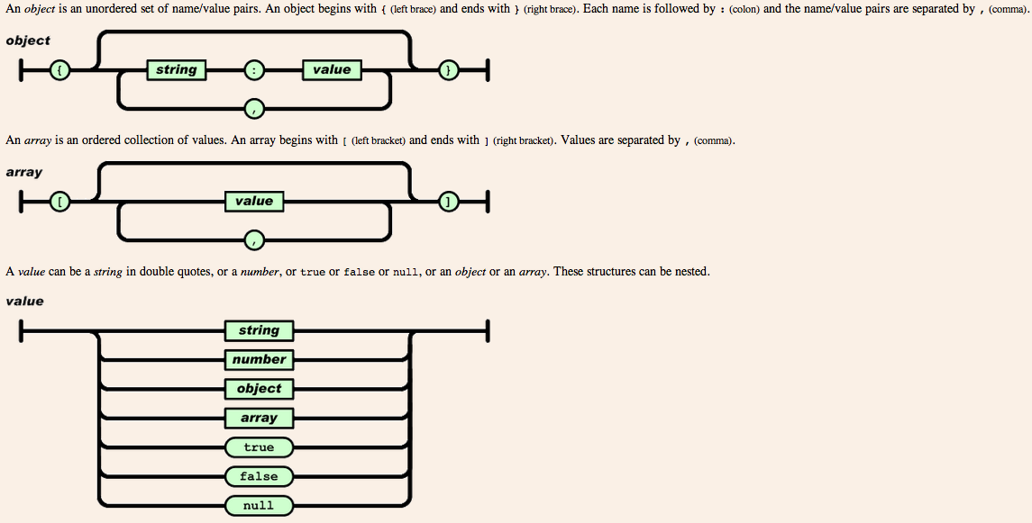

Here is a quick compare of the same data shown in XML and JSON from the json.org site.

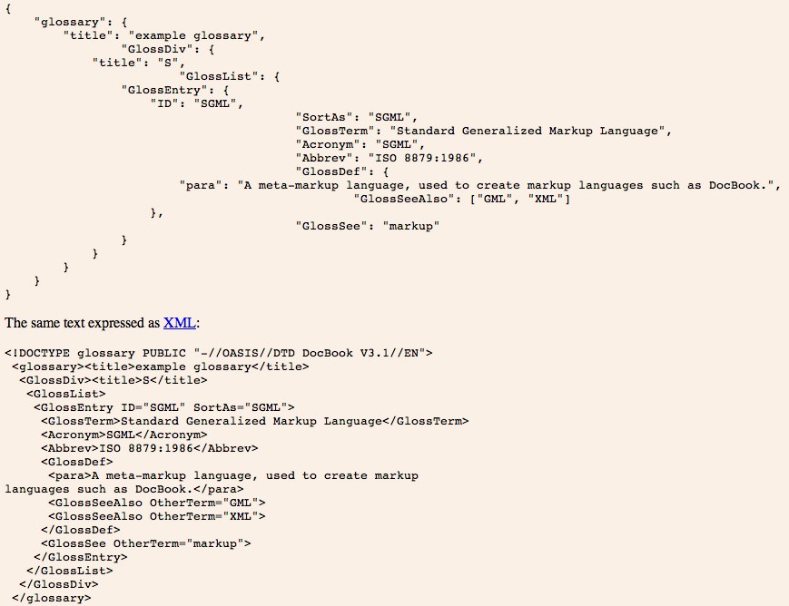

|  |  |
| --- | --- |
| Let’s get back to using the Rotten Tomatoes API and create a quick application that pulls data from the RottenTomatoes.com web site and display it on our iPhone/iPod/iPad. When we are done the application should look like the following. |  |

**Prerequisite:** Before we get started we need to get an API Key. This is usually a collection of characters that identify the user that is using the API.

**Step P1:** Navigate to the web site <http://developer.rottentomatoes.com/> and click the register link in the top right hand corner.

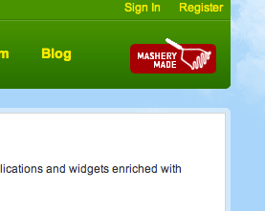

**Step P2:** Enter the required information. Here is a sample of information for the application.

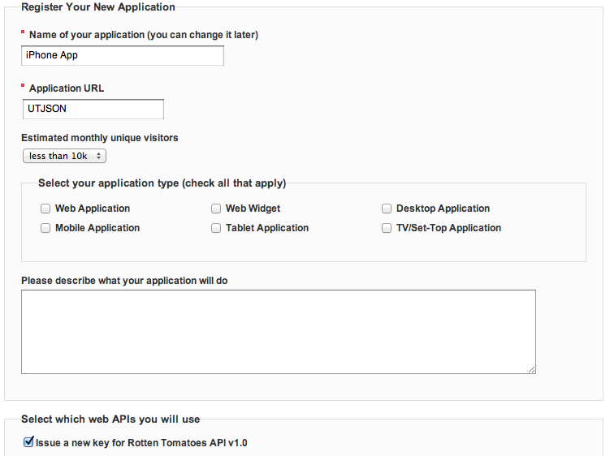

**Step P3:** Validate email address with the email they send.

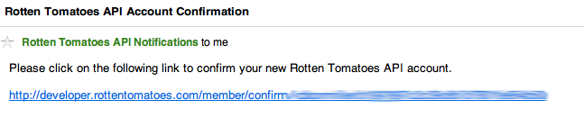

**Step P4:** Record your API key sent to you after you validated your email.

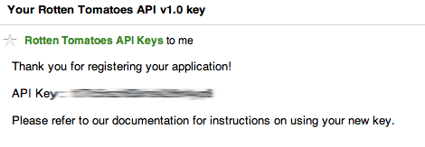

**Step 1:** Start a new View-Based Application.

|  |  |  |  |
| --- | --- | --- | --- |
| |  |  | | --- | --- | |  |  | |  |

**Step 2:** We will need to use a framework to parse the JSON notation. There are two big players that are available. There is the JSONKit, available as open source on [GitHub.com from John Englehart](http://github.com/johnezang/JSONKit). This is the framework that I feel is easiest to install and has the necessary features. I have included this class in a zip file on the Black Board. It is the same code you will get from the GitHub link. The class is a collection of C and Objective-C code. It is probably a bit complex, but that is the beauty of open source. We do not need to understand all of the code, we just need to know how to implement it. That is what we will do in the following steps. Let’s copy the class into our supporting files.

|  |  |
| --- | --- |
|  |  |

**Step 3:** Now let’s apply our design to the JSONRottenTomatoesViewController.xib file.

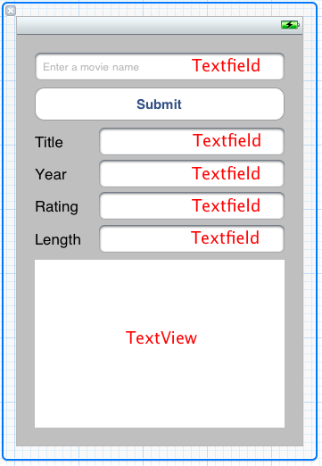

**Step 4:** Now let’s create the IBOUTLETS and IBACTION in the header file

#import <UIKit/UIKit.h>

@interface JSONRottenTomatoesViewController : UIViewController

{

IBOutlet UITextField *txtSearch;

IBOutlet UITextField *txtTitle;

IBOutlet UITextField *txtYear;

IBOutlet UITextField *txtRating;

IBOutlet UITextField *txtRuntime;

IBOutlet UITextField *txtMovieRelease;

IBOutlet UITextField *txtDVDRelease;

IBOutlet UITextView *txtOutput;

}

@property (nonatomic, retain) IBOutlet UITextField *txtSearch;

@property (nonatomic, retain) IBOutlet UITextField *txtTitle;

@property (nonatomic, retain) IBOutlet UITextField *txtYear;

@property (nonatomic, retain) IBOutlet UITextField *txtRating;

@property (nonatomic, retain) IBOutlet UITextField *txtRuntime;

@property (nonatomic, retain) IBOutlet UITextView *txtOutput;

-(IBAction)parseJSON:(id)sender;

@end

**Step 5:** Now let’s connect the outlets and action to the xib file.

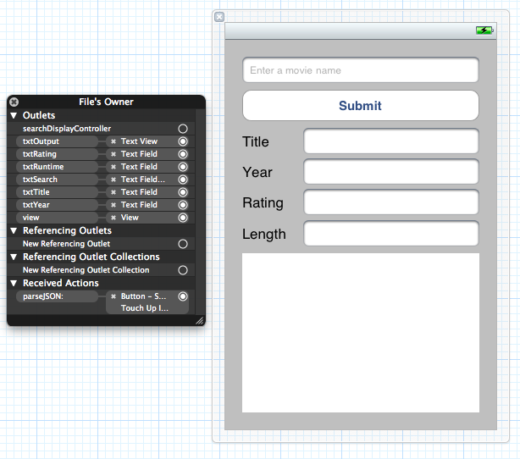

**Step 6:** Synthesize the variables in the implementation file. Also, we need to import the JSONKit.h

#import "JSONKit.h"

@synthesize txtTitle, txtYear, txtRating, txtRuntime;

@synthesize txtOutput, txtSearch;

**Step 7:** Let’s build the parseJSON method. This is the heart of the application.

-(IBAction)parseJSON:(id)sender

{

// Format search bar

NSString* formattedSearch = [txtSearch.text stringByReplacingOccurrencesOfString:@" " withString:@"+"];

// Variable to store our API Key

NSString* const RT_API_KEY = @"blahblahblah"; // This is where you put your API key

NSString* searchURL = [NSString stringWithFormat:@"http://api.rottentomatoes.com/api/public/v1.0/movies.json?apikey=%@&q=%@", RT_API_KEY, formattedSearch];

NSLog(@"%@", searchURL);

// Variables to handle errors

NSError* error = nil;

NSURLResponse* response = nil;

NSMutableURLRequest* request = [[[NSMutableURLRequest alloc] init] autorelease];

NSURL* URL = [NSURL URLWithString:searchURL];

[request setURL:URL];

[request setCachePolicy:NSURLRequestReloadIgnoringLocalCacheData];

[request setTimeoutInterval:30];

NSData* data = [NSURLConnection sendSynchronousRequest:request returningResponse:&response error:&error];

if (error)

{

[txtOutput setText:[NSString stringWithFormat:@"Error performing request %@", searchURL]];

}

NSString *jsonString = [[NSString alloc] initWithData:data encoding:NSUTF8StringEncoding];

jsonString = [jsonString stringByTrimmingCharactersInSet:[NSCharacterSet whitespaceAndNewlineCharacterSet]];

[txtOutput setText:[NSString stringWithFormat:@"%@", jsonString]];

NSLog(@"Here is what we got %@", jsonString);

NSDictionary *results = [jsonString objectFromJSONString];

NSArray *movieArray = [results objectForKey:@"movies"];

// Search for year to match

for (NSDictionary *movie in movieArray)

{

NSString *title = [movie objectForKey:@"title"];

NSNumber *year = [movie objectForKey:@"year"];

NSString *rating = [movie objectForKey:@"mpaa_rating"];

NSNumber *runtime = [movie objectForKey:@"runtime"];

txtTitle.text = title;

[txtYear setText:[NSString stringWithFormat:@"%d", [year integerValue]]];

txtRating.text = rating;

[txtRuntime setText:[NSString stringWithFormat:@"%d minutes", [runtime integerValue]]];

// Get dvd and theater release

NSDictionary *deserializedData = [data objectFromJSONData];

NSDictionary *release_dates = [deserializedData objectForKey:@"release_dates"];

NSString *theaterRelease = [release_dates objectForKey:@"theater"];

NSLog(@"Movie Release = %@", theaterRelease);

NSString *dvdRelease = [release_dates objectForKey:@"dvd"];

NSLog(@"DVD Release = %@", dvdRelease);

}

[txtSearch resignFirstResponder];

}

**Step 8:** Let’s just implement a method to hide the keyboard if we touch anywhere else on the screen.

-(void)touchesBegan:(NSSet *)touches withEvent:(UIEvent *)event

{

UITouch *touch = [touches anyObject];

if (touch != nil)

{

[txtSearch resignFirstResponder];

}

}

Congrats!!!! We are done. It should look something like this:

